Safety Instruction
- Users are required to read the operation manual completely and carefully before installation or operation.
- The product should be installed and pre-operated by well-trained persons. All power supplies must be turned off during the installation work, remember not to operate with power on.
- All the instruction marked with sign must be observed or executed; otherwise, bodily injuries might occur.
- For perfect operation and safety, it is prohibited that using extension cable with multi-outlet for power connection.
- When connecting the power cord, it must be determined that the operating voltage conforms to the rated voltage value specified in the product identification.
- Don＇t operate in direct sun light，outdoors area and where the room temperature is over 45°C or below 0°C.
- Please avoid operating near the heater at dew area or at the humidity below 10% or above 90%.
- Don＇t operate in area with heavy dust, corrosive substance or volatile gas.
- Avoid power cord being applied by heavy objects or excessive force, or over bend.
- The earth wire of power cord must be connected to the system ground of the production plant by proper size of conductions and terminals. This connection should be fixed permanently.
- All the moving portions must be prevented to be exposed by the parts provided.
- Turing on the machine in the first time, operate the sewing machine at low speed and check the correct rotation direction.
- Turn off the power before the following operation:
1. Connecting or disconnecting any connectors on the control box or motor.
2. Threading needle.
3. Raising the machine head.
4. Repairing or doing any mechanical adjustment.
5. Machines idling.
- Repairs and high level maintenance work should only be carried out by electronic technicians with appropriate training.
- All the spare parts for repair must be provided or approved by the manufacturer.
- Don’t use any objects or force to hit or ram the product.
Guarantee Time
Warranty period of this product is 1 year dated from purchasing, or within 2 years from ex-factory date.
Warranty Detail
Any trouble found within warranty period under normal operation, it will be repaired free of charge. However, maintenance cost will be charged in the following cases even if within warranty period:
1. Inappropriate use, including: wrong connecting high voltage, wrong application, disassemble, repair, modification by incompetent personnel, or operation without the precaution, or operation out of its specification range, or inserting other objects or liquids into the product.
2. Damage by fire, Earth quake, lighting, wind, flood, salt corrosive, moisture, abnormal power voltage and any other damage cause by the natural disaster or by the inappropriate environments.
3. Dropping after purchasing or damage in transportation by customer himself or by customer’s shipping agency
* We make our best effort to test and manufacture the product for assuring the quality. However, it is possible that this product can be damaged due to external magnetic interference and electronic static or noise or unstable power source more than expected; therefore the grounding system of operate area must guarantee the good earth and it’s also recommended to install a failsafe device (Such as residual current breaker).

1 Startup interface instructions
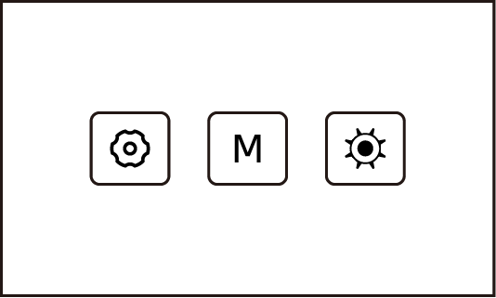

Name | Key | Indicate
M key |  | If press, enter the main interface.
Debugging key |  | If press, enter the mechanical adjustment interface.
Reserved | 

2 Main interface instructions
2.1 Main interface instructions
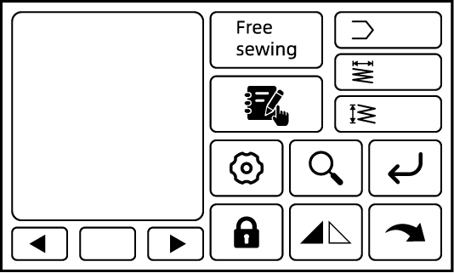

Name | Key | Indicate
Pattern number |  | Displays the current pattern number in use.
Horizontal coordinate |  | Displays the current stitch length of swing needle.
Vertical coordinate |  | Displays the current stitch length of tacking and back-tacking.
Free sewing |  | If press, switch to free sewing mode.
Target stitch sewing | 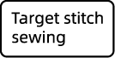 | If press, switch to target stitch sewing mode.
Pattern selection |  | If press, enter the common pattern selection and registration interface.
Setting key |  | If press, enter the parameter setting interface.
Pattern finding |  | If press, enter the pattern browsing interface.
Confirm |  | If press, uses the currently displayed pattern in the pattern display box.
Lock screen |  | If press, switch between lock screen or unlock.
Mirror image |  | If press, the selected pattern generates a left and right mirror pattern.
Next level |  | If press, enter the secondary main interface
Page up |  | If press, switch to display the previous pattern.
Page down |  | If press, switch to display the next pattern.
Note: Long-press the pattern button in the main interface to view the pattern data, and re-edit the pattern data for the new pattern created by the customer.

2.2 Secondary main interface instructions
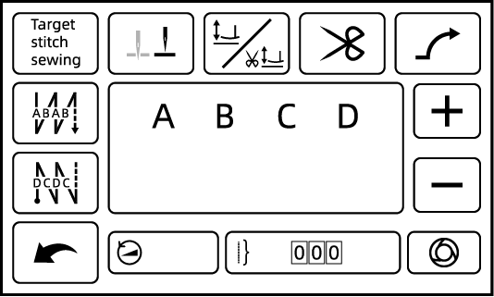

Name | Key | Indicate
Free sewing |  | If press, switch to free sewing mode.
Target stitch sewing | 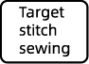 | If press, switch to target stitch sewing mode.
Start back-tacking | 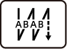 | If press, switch AB start back-tacking → ABAB start back-tacking → function off → B start back-tacking successively.
End back-tacking |  | If press, switch CD end back-tacking → CDCD end back-tacking → function off → C end back-tacking successively.
Reserved | 
Needle stop position selection | 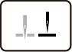 | If press, the needle stop position after shift the sewing mode (upper position / lower position).
Reserved | 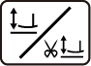
Soft start |  | If press, set used or cancelled soft start function.
Previous level |  | If press, return to the previous main screen.
Parameter increasing |  | If press, the parameter will be increased.  If long-press, the parameter will be continuously increased.
Parameter decreasing |  | If press, the parameter will be decreased.  If long-press, the parameter will be continuously decreased.
Auto function |  | In Target stitch sewing, if press, set used or cancelled auto function.
Speed |  | If press, this data is selected and can be adjusted.
Segment number |  | If press, this data is selected and can be adjusted.
The number of stitches |  | If press, this data is selected and can be adjusted.

3 Setting interface
In the main screen, press to enter the setting interface, the setting interface directory is as follows.
No. | Directory
1 | Parameter setting
2 | Interface display
3 | Pattern setting
4 | About system
5 | Mechanical adjustment
6 | Other functions

No. | Items | Range | Default | Description
3.1 Parameter setting
3.1.1 P parameter
1 | Parameter number
2 | Parameter value
3.1.2 Panel parameter (reserved)
3.1.3 Statistical function
1 | The number of bobbin thread stitches count mode | 0-4 | 0 | 0: OFF  1: Incremental cycle counting  2: Decremental cycle counting  3: Incremental counting, alarm after counting full, need to be cleared by the key to start re-counting.  4: Decremental counting, alarm after counting full, need to be cleared by the key to start re-counting.
2 | Upper limit of the number of bobbin thread stitches*10 (stitches) | 0-9999 | 500 | The alarm will be activated when the number of bobbin thread stitches reaches 5000.
3 | Upper limit of the number of maintenance stitches*100000 (stitches) | 0-9999 | 9000
4 | The number of bobbin thread stitches |  | 0
5 | The number of maintenance stitches |  | 0
3.1.4 Pedal parameter
1 | Pedal mode | 0-3 | 0 | 0: Factory mode  1: Beginner mode  2: Standard mode  3: Proficiency mode
2 | Acceleration curve adjustment | 0-100 | 80
3 | Pedal hysteresis mode | 0-2 | 0 | 0: 1 stitch is well controlled, 2 stitches slightly less so.  1: 1 stitch is slightly better controlled, 2 stitches are slightly better controlled.  2: 1 stitch is slightly difficult to control, 2 stitches are good.
4 | The position of pedal for accelerating | 30-1000 | 580
5 | The position of pedal for starting | 30-1000 | 480
6 | The position of pedal for presser foot lifting | 30-1000 | 230
7 | The position of pedal for trimming | 30-500 | 110
8 | Front pedaling acceleration | 0-40 | 10 | The larger the value, the greater the acceleration of front pedaling.
9 | Front pedaling sensitivity | 0-20 | 12 | The larger the value, the less sensitive it is, and one stitch is better controlled.
19 | Half back pedaling function starting time | 10-900 | 100
3.1.5 P42
1 | N parameter | 1-200 | 1 | N01: Control box version number  N02: Pedal version number  N03: Real-time RPM  N04: Pedal AD value  N06: Main shaft angle when needle out of cloth  N07: Busbar AD value
3.2 Interface display
1 | Brightness | 5-100 | 50
2 | Main interface auto-lock time | 0-999 | 30 | 0: OFF
3 | Language |  | Chinese
3.3 Pattern setting
3.3.5 Pattern parameter
3.3.5.1 Tacking and back-tacking compensation setting
1 | Tacking and back-tacking compensation mode | 0-3 | 0 | 0: OFF  1: Tacking stitch length overall compensation is displayed.  2: Tacking stitch length overall compensation and tacking stitch length overall compensation in high speed are displayed.  3: Tacking stitch length overall compensation, tacking stitch length overall compensation in high speed and stitch length compensation of back-tacking when cornering are displayed.
2 | Tacking stitch length overall compensation | -100~100 | 0
3 | Back-tacking stitch length overall compensation | -100~100 | 0
4 | Tacking stitch length overall compensation in high speed | -100~100 | 0 | Effective above 1000 RPM.
5 | Back-tacking stitch length overall compensation in high speed | -100~100 | 0 | Effective above 1000 RPM.
6 | Stitch length compensation 1 of back-tacking when cornering | -100~100 | 0
7 | Stitch length compensation 2 of back-tacking when cornering | -100~100 | 0
3.4 About system
3.4.1 Version number
 | Master version
 | Driver 1 version
 | Driver 2 version
 | Panel version
 | Resource version
3.5 Mechanical adjustment
3.5.1 Panel related
1 | Model selection | 0-200 | 1
2 | Restore factory defaults | 0 | 9999 | Enter the version number to restore factory settings.
3.5.2 Machine debugging
1 | Back-tacking stepping motor zero-point correction | -500~500 | 0
2 | Maximum stitch length limit (mm) | 0-70 | 40
3 | Stitch length reference value correction
4 | Swing needle stepping motor zero-point correction | -500~500 | 0
5 | Maximum swing limit of swing needle | 0-90 | 80
6 | Swing needle motor swing angle | 0-1800 | 220
7 | Main shaft motor electrical angle correction |  | 160
8 | Upper positioning quick adjustment |  | 0
9 | Machine button / oil level detection |  | 248 | Used for after-sales maintenance.
10 | Electric knee-control detection |  |  | Reserved
11 | Electric wrench detection |  |  | Reserved

4 Port diagram
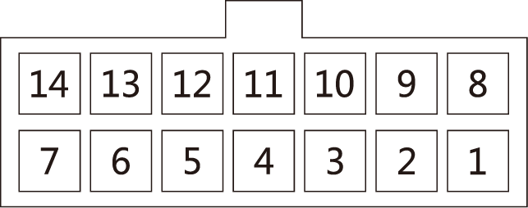
1. LED light: 4, 11 (+5V)
2. Back-tacking button: 5 (signal), 12 (DGND)
3. Darning stitch button: 7 (signal), 14 (DGND)

