Safety Instruction
- Users are required to read the operation manual completely and carefully before installation or operation.
- The product should be installed and pre-operated by well-trained persons. All power supplies must be turned off during the installation work, remember not to operate with power on.
- All the instruction marked with sign must be observed or executed. Otherwise, bodily injuries might occur.
- For perfect operation and safety, it is prohibited that using extension cable with multi-outlet for power connection.
- When connecting the power cord, it must be determined that the operating voltage conforms to the rated voltage value specified in the product identification.
- Don＇t operate in direct sun light，outdoors area and where the room temperature is over 45°C or below 0°C.
- Please avoid operating near the heater at dew area or at the humidity below 10% or above 90%.
- Don＇t operate in area with heavy dust, corrosive substance or volatile gas.
- Avoid power cord being applied by heavy objects or excessive force, or over bend.
- The earth wire of power cord must be connected to the system ground of the production plant by proper size of conductions and terminals. This connection should be fixed permanently.
- All the moving portions must be prevented to be exposed by the parts provided.
- Turing on the machine in the first time, operate the sewing machine at low speed and check the correct rotation direction.
- Turn off the power before the following operation:
1. Connecting or disconnecting any connectors on the control box or motor.
2. Threading needle.
3. Raising the machine head.
4. Repairing or doing any mechanical adjustment.
5. Machines idling.
- Repairs and high level maintenance work should only be carried out by electronic technicians with appropriate training.
- All the spare parts for repair must be provided or approved by the manufacturer.
- Don’t use any objects or force to hit or ram the product.
Guarantee Time
Warranty period of this product is 1 year dated from purchasing, or within 2 years from ex-factory date.
Warranty Detail
Any trouble found within warranty period under normal operation, it will be repaired free of charge. However, maintenance cost will be charged in the following cases even if within warranty period:
1. Inappropriate use, including: wrong connecting high voltage, wrong application, disassemble, repair, modification by incompetent personnel, or operation without the precaution, or operation out of its specification range, or inserting other objects or liquids into the product.
2. Damage by fire, Earth quake, lighting, wind, flood, salt corrosive, moisture, abnormal power voltage and any other damage cause by the natural disaster or by the inappropriate environments.
3. Dropping after purchasing or damage in transportation by customer himself or by customer’s shipping agency
* We make our best effort to test and manufacture the product for assuring the quality. However, it is possible that this product can be damaged due to external magnetic interference and electronic static or noise or unstable power source more than expected. Therefore the grounding system of operate area must guarantee the good earth and it’s also recommended to install a failsafe device (Such as residual current breaker).

1 Key displays and operating instructions
  - Key description
Name | key | Indicate
Function key |  | If click, enter or exit the user parameter setting interface.
Confirm key |  | If press, the machine will be locked / unlocked. (Standby interface)  If press, check and save the content of the selected parameter number: after selecting the parameter number, press this key to check and modify the operation, after modifying the parameter value, press this key to exit and save the parameter. (Parameter interface)
Parameter increasing |  | If press, the parameter value will be increased. (Parameter interface)  If long-press, the parameter value will be continuously increased. (Parameter interface)  If press, the speed value will be increased. (Standby interface)  If long-press, the speed value will be continuously increased. (Standby interface)
Parameter decreasing |  | If press, the parameter value will be decreased. (Parameter interface)  If long-press, the parameter value will be continuously decreased. (Parameter interface)  If press, the speed value will be decreased. (Standby interface)  If long-press, the speed value will be continuously decreased. (Standby interface)
Left selection |  | If press, the parameter bit will be shifted left. (Parameter interface)
Right selection |  | If press, the parameter bit will be shifted right. (Parameter interface)  If press, blowing once. (Standby interface)  If long-press, keep blowing. (Standby interface)
Cutter |  | If press, set to use or cancel the cutter function. (Standby interface)  If long-press, switch to manual cutter mode. (Standby interface)
Sewing thread detection / Presser foot |  | If press, set to use or cancel the sewing thread detection function. (Standby interface)  If long-press, set to use or cancel the presser foot function. (Standby interface)

1.2 Operating instructions
1.2.1 Reset
Long-press and at the same time, and turn on the machine. RST is displayed, press to confirm, OFF is displayed, press or to change to ON, and press to confirm. After RST is displayed, the system will shut down and restart.
1.2.2 Piece counting is reset
In the main interface, Long-press and at the same time to zero out the piece counting.
1.2.3 Lock and unlock
In the main interface, press to switch between motor locked and motor unlocked, the default state is locked when the machine is turned on. When locked, the interface displays LOCK, the presser foot will lower, back pedaling can make presser foot lift and front pedaling will be no response, press or to modify the running speed. When unlocked, the interface will show a dynamic zero, if machine is in the origin position then presser foot will lift, half front pedaling can make presser foot lower, front pedaling can start the machine; if it is not in the original position, front pedaling can make the machine run once, and the machine will stop in the original position.

2 User parameters & technician parameters
2.1 User parameters
No. | Items | Range | Default | Description
P01 | High running speed (rpm) | 100-3000 | 3000
P02 | Low running speed (rpm) | 100-3000 | 100
P03 | Cutter speed | 100-3000 | 800
P04 | Speed limit of the first stitch | 100-3000 | 800
P05 | Speed limit of the second stitch | 100-3000 | 800
P06 | Speed limit of the third stitch | 100-3000 | 2000
P07 | Speed limit of the fourth stitch | 100-3000 | 2500
P09 | Presser foot protection time | 1-600 | 60
2.2 Technician parameters
No. | Items | Range | Default | Description
P10 | Cutter switch | 0-2 | 1 | 0: OFF  1: ON  2: Continuous cutting
P11 | Cutting function switch after broken thread detection | 0-1 | 0
P13 | Stepping motor zero-point compensation | -100~800 | -100 | Fine-tuning the mechanical origin position of the stepping motor.
P14 | Main shaft motor zero-point correction |  |  | Press  in the parameter adjustment interface, main shaft motor will automatically find the zero-point, and press  to save after completion.
P15 | The number of protection stitches when machine stopping | 1-990 | 30 | If feed cam can't sense the stopping signal, how many stitches are to be actuated by the machine needle for protection.
P16 | The number of protection stitches when machine decelerating | 1-990 | 300 | If feed cam can't sense deceleration signal, how many stitches are to be actuated by the machine needle for protection.
P17 | Automatically find the upper position after power-on | 0-1 | 1 | 0: OFF  1: ON
P18 | Upper position adjustment | 1-2400 | 90 | Upper position adjustment, needle stops early when value is decreased, needle stops late when value is increased.
P19 | Test running time (0.1s) | 1-250 | 30
P20 | Test stopping time (0.1s) | 1-50 | 10
P21 | Testing A | ON/OFF | OFF | Testing A, after setting, a continuous running test will be performed at the speed of P01.
P22 | Testing B | ON/OFF | OFF | Testing B, after setting, a full functional test will be performed at the speed of P01.
P23 | Testing C | ON/OFF | OFF | Testing C, after setting, a test without positioning will be performed at the speed of P01.
P24 | Machine protection switch selection | 0-1 | 1 | 0: OFF  1: ON
P25 | Stopping speed | 100-500 | 210
P26 | Maximum speed | 100-3600 | 3000
P27 | Upper position quick adjustment | 0-2400 |  | Upper position adjusting, the displayed value will change with the change of handwheel position, press to save the current position (value) as the upper position.
P28 | Maximum height of presser foot | 0-2400 | 700 | The height of presser foot lifting when machine starting.  Note: The height value is the pulse value, 2400 means that the stepping motor has rotated 360°.
P29 | Presser foot speed | 20-800 | 150
P30 | Presser foot switch when locking the machine | 0-1 | 0 | When the machine is turned on, presser foot can be lifted by back pedaling in the locked state.
P31 | The running position of front pedaling | 30-1000 | 750 | Starting position in high speed.
P32 | The position of the pedal for stopping | 30-1000 | 420
P33 | The position of half front pedaling | 30-1000 | 600 | Starting position in low speed.
P34 | The position of back pedaling | 30-1000 | 130
P37 | Presser foot switch | 0-1 | 1 | 0: OFF  1: ON
P39 | Back pedaling selection when pause | 0-1 | 0 | 0: OFF  1: ON
P41 | Piece counting | 0-9999 | 1 | Long-press to zero out.
P42 | Information display | N01-N07 |  | N01 Electronic control version number serial number  N02 Penal version number  N03 Speed  N04 Pedal AD  N05 Upper positioning mechanical angle  N06 Lower positioning mechanical angle  N07 Busbar voltage AD  N18 Stepping motor angle adjustment
P43 | Model selection | 0-3 | 3
P44 | Presser foot holding strength | 0-5 | 3
P45 | Presser foot lifting when pause | 0-1 | 0
P46 | Broken thread detection switch | 0-1 | 0 | 0: OFF  1: ON
P47 | Cutter speed | 50-800 | 300
P48 | Cutter angle | 0-359 | 150
P49 | The number of delayed stitches | 0-99 | 0
P50 | Continuous cutting mode | 0-1 | 0 | 0: OFF  1: ON
P51 | Cutter holding time | 20-300 | 1
P52 | The number of stitches for the first cutting in continuous cutting mode | 0-300 | 27 | When P10=2, set the number of stitches needed for the lower cutter, same for P53-P56.
P53 | The number of stitches for the second cutting in continuous cutting mode | 0-300 | 28
P54 | The number of stitches for the third cutting in continuous cutting mode | 0-300 | 55
P55 | The number of stitches for the fourth cutting in continuous cutting mode | 0-300 | 56
P56 | The number of stitches for the fifth cutting in continuous cutting mode | 0-300 | 75
P57 | Broken thread detection setting | 0-1 | 0 | 0: Stopping immediately when thread is breaking to report the abnormality.  1: After breaking, reporting the abnormality after an emergency stop / stopping after sewing
Note: the initial value of parameters is for reference only, and the actual value of parameters is subject to the real object.

3 Error code list
Error Code | Problem | Measure
E01 | High voltage | 1. Whether the grid voltage is higher than AC260V.  2. If it is self-generated power supply, please reduce the generator power.  3. If it still does not work normally, please replace the control box and notify the after-sales service.
E02 | Low voltage | 1. Whether the grid voltage is lower than AC160V.  2. Reset.  3. If it still does not work normally, please replace the control box and notify the after-sales service.
E03 | CPU communication abnormal | 1. Turn off the system power and check whether the connection of the display screen is loose or disconnected, restart the system after returning it to normal.  2. Turn off the system power, remove the control box and only plug in the power cord to power on, whether alarm E05, if it still alarms E03, replace the control box and notify the after-sales service.
E05 | Pedal signal abnormal | 1. Check whether the pedal connector is loose or fall off, and restart the system after returning it to normal.  2. If it still does not work normally, please replace the control box or speed controller and notify the after-sales service.
E06 | Stepping motor cannot return to origin | 1. Manually turn the feed cam to origin.  2. Check the stepping motor assembly problem, if the assembly is bad, please reassemble.  3. Turn off the system power and restart.
E07 | Main shaft motor locked-rotor | 1. Turn off the power and check whether the handwheel can be turned smoothly (turn the handwheel by hand), if it cannot be turned, please check the machine;  2. Turn off the power, check whether the motor power connector is loose, plug it in and restart it;  3. Check whether the upper needle stop position is correct, if not, please adjust the upper positioning position;  4. If it still does not work normally, please replace the control box or main shaft motor and notify the after-sales service.
E10 | Electromagnet overcurrent | 1. Unplug the solenoid connector, if alarm E10, replace the control box and notify the after-sales service.  2. If there is no alarm after removing the solenoid connector, please plug it back in.
E11 | The positioning signal of main shaft motor encoder is abnormal | 1. Turn off the system power, check whether main shaft motor encoder connector is loose or fall off, restore it to normal and restart the system.  2. Check whether the motor zero point correction setting is correct; reset the motor zero point correction; Whether there is oil on the encoder code plate, please clean it if there is any;  3. If it still does not work normally, please replace the control box or main shaft motor and notify the after-sales service.
E14 | Main shaft motor encoder signal is abnormal | 1. Turn off the system power, check whether the main shaft motor encoder connector is loose or fall off, restore it to normal and restart the system.  2. Check whether the grating is installed correctly (whether the grating screws are tightened and whether the grating is in the center of the encoder).  3. Check whether there is oil on the encoder code plate, if there is, please clean it up, and restart the system after recovery.  4. If it still does not work normally, please replace the control box or main shaft motor and notify the after-sales service.
E15 | Main shaft motor drive overcurrent | 1. Please check whether the motor power cord has bad contact.  2. Please check whether the motor power cord is crushed.  3. Please replace the control box or main shaft motor and notify the after-sales service.
E17 | Machine overturned | 1. Turn off the system power and check if the machine is overturned.  2. Check whether the machine protection switch detection setting is correct.  3. If it still does not work normally, please replace the control box or panel and notify the after-sales service.  Press to cancel the alarm once.
E19 | The feed cam deceleration sensor is not in the correct position | Check whether the position of feed cam is normal and whether the deceleration sensor is damaged.
E20 | The feed cam stopping sensor is not in the correct position | Check whether the position of feed cam is normal and whether the stop sensor is damaged.
E25 | Broken thread detection | Please check upper thread.  Press to cancel the alarm at once.
E82 | Stepping motor overcurrent | 1. Turn off the system power and observe whether stepping motor is stuck. If it is stuck, remove the mechanical failure of the machine first. If it is normal, check whether connector of stepping motor is loose or fall off, restore it to normal and restart the system.  2. If it still does not work normally, please replace the control box or stepping motor and notify the after-sales service.
E84 | The positioning signal of stepping motor encoder is abnormal | 1. Turn off the system power and observe whether stepping motor is stuck. If it is stuck, remove the mechanical failure of the machine first. If it is normal, check whether the encoder connector of stepping motor is loose or fall off, and restart the system after returning it to normal.  2. Check whether the grating is installed correctly (whether the grating screws are fastened and whether the grating is in the center of the encoder);  3. Check if there is oil on the grating code plate, if so, please clean it up, and restart the system after restoration;  4. If it still does not work normally, please replace the control box or stepping motor and notify the after-sales service.
E85 | Stepping motor encoder signal is abnormal | 1. Turn off the power of the system, check whether the encoder connector of stepping motor is loose or fall off, restore it to normal and restart the system.  2. Check whether the grating is installed correctly (whether the grating screws  are fastened and whether the grating is in the center of the encoder);  3. Check if there is oil on the grating code plate, if so, please clean it up, and  restart the system after restoration;  4. If it still does not work normally, please replace the control box or stepping motor and notify the after-sales service.
E86 | Stepping motor failed to start | 1. Turn off the power of the system, check whether the power cord connector of stepping motor and the encoder connector are loose or fall off, restore them to normal and restart the system.  2. Check whether the grating is installed correctly (whether the grating screws are fastened and whether the grating is in the center of the encoder);  3. Check if there is oil on the grating code plate, if so, please clean it up, and  restart the system after restoration;  4. If it still does not work normally, please replace the control box or stepping motor and notify the after-sales service.
E87 | Stepping motor locked-rotor | 1. Turn off the system power and observe whether stepping motor is stuck. If it is stuck, remove the mechanical failure of the machine first. If it is normal, check whether the power cord connector of motor and the encoder connector are loose or fall off, restore them to normal and restart the system.  2. If it still does not work normally, please replace the control box or stepping motor and notify the after-sales service.

4 Port diagram
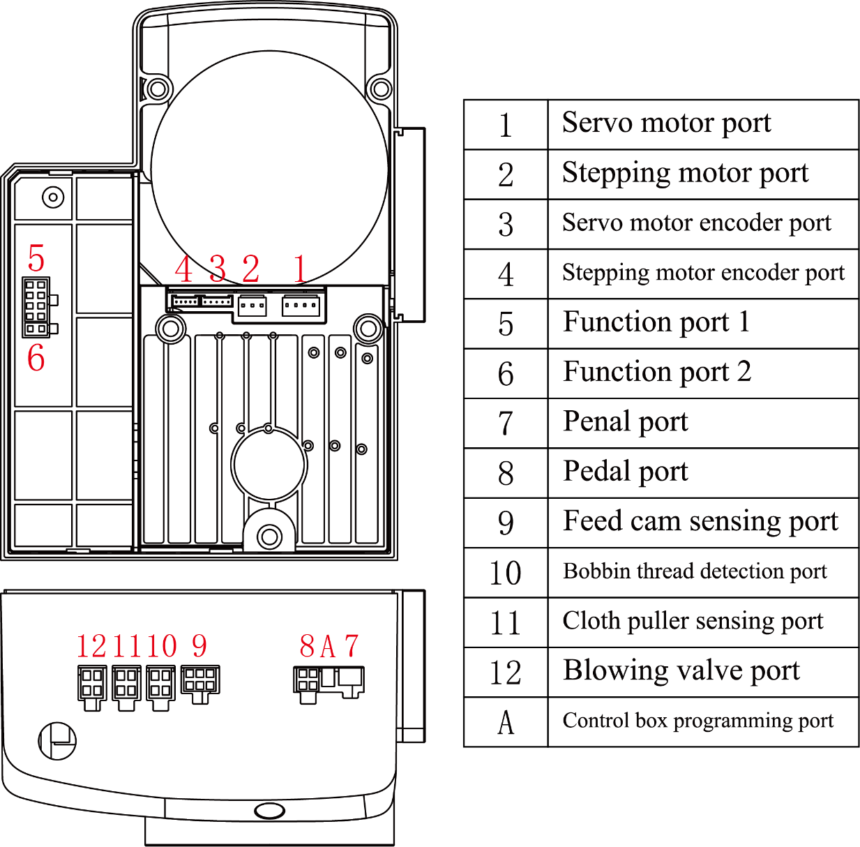

Function port 1 description
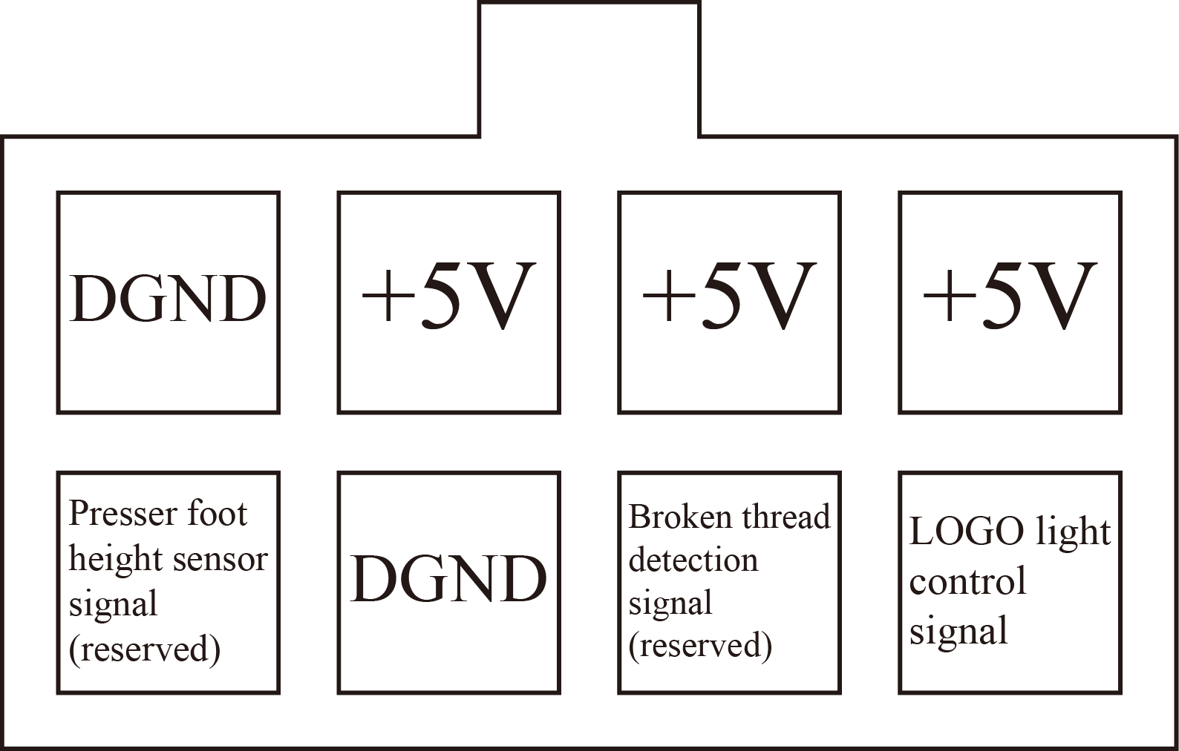

Function port 2 description (reserved)


Feed cam sensing port description
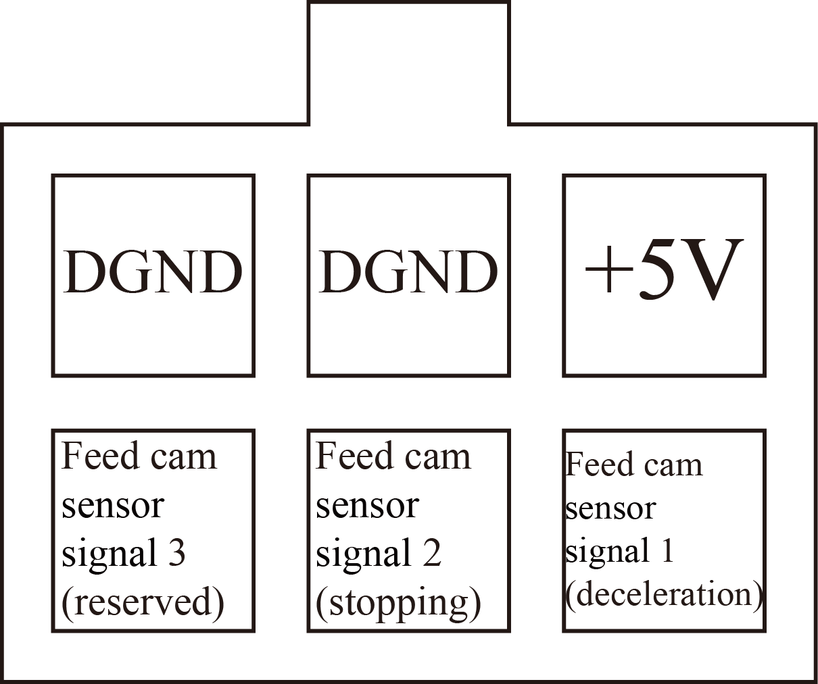

Bottom thread detection port description (red) (reserved)
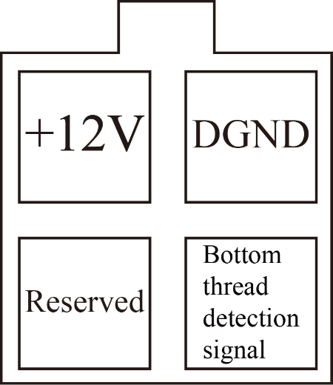

Cloth puller sensing port description (blue) (reserved)
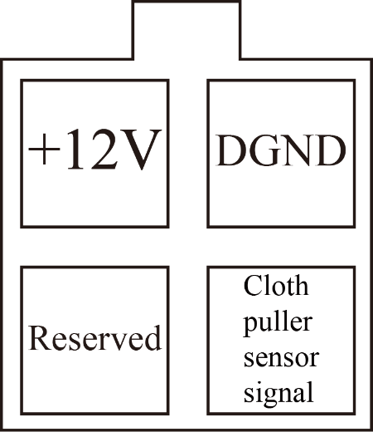

Blowing valve port description (orange) (reserved)
